Lab 3 tasks
Abdullah Ahmad | BCS – 3C | K25-0084

Q1.
#include <iostream>
using namespace std;

class Catalog
{
public:
string title;
string author;
string genre;
double price;
};

void printAllEntries(Catalog o1, Catalog o2, Catalog o3)
{
cout << "\nTitle: " << o1.title << endl;
cout << "Author: " << o1.author << endl;
cout << "Genre: " << o1.genre << endl;
cout << "Price: $" << o1.price << endl;

cout << "\nTitle: " << o2.title << endl;
cout << "Author: " << o2.author << endl;
cout << "Genre: " << o2.genre << endl;
cout << "Price: $" << o2.price << endl;

cout << "\nTitle: " << o3.title << endl;
cout << "Author: " << o3.author << endl;
cout << "Genre: " << o3.genre << endl;
cout << "Price: $" << o3.price << endl;
}

void printAllEntries_2(Catalog o[], int n)
{
for (int i = 0; i < n; i++)
{
cout << "\nTitle: " << o[i].title << endl;
cout << "Author: " << o[i].author << endl;
cout << "Genre: " << o[i].genre << endl;
cout << "Price: $" << o[i].price << endl;
}
}

int main()
{
Catalog c1, c2, c3;
c1 = {"Dragon Ball", "Akira toriyama", "Shounen", 24.99};
c2 = {"Bleach", "Tite Kubo", "Sheinen", 25.99};
c3 = {"Hunter X Hunter", "Unknown", "horror", 26.99};

Catalog arr[3] = {c1, c2, c3};

printAllEntries(c1, c2, c3); // hard coded
printAllEntries_2(arr, 3); // variable number of objects

return 0;
}
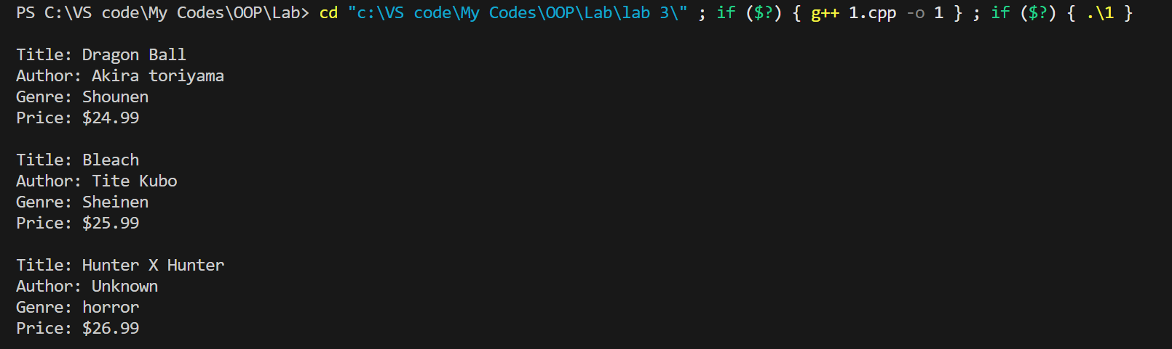

Q2.
#include <iostream>
#include <string>
using namespace std;

class EmployeeData
{
double salary;

public:
string name;
string title;

EmployeeData(string n, string t, double sal) : name(n), title(t), salary(sal) {}

void setSalary(double s)
{
salary = s;
}

double getSalary()
{
return salary;
}

void printDetails()
{
cout << "\nName: " << name << endl;
cout << "Job Title: " << title << endl;
cout << "Salary: $" << getSalary() << endl;
}
};

int main()
{
EmployeeData e1("Abdullah Ahmad", "CEO", 10500); // using contructor
// e1.name = "Abdullah Ahmad";
// e1.title = "CEO"; // using setter & getter
// e1.setSalary(10500);
e1.printDetails();

return 0;
}

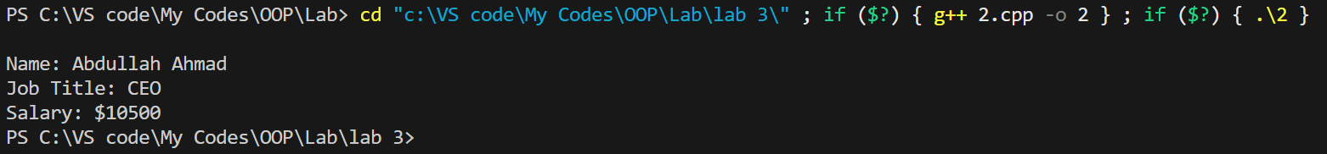

Q3.
#include <iostream>
#include <string>
using namespace std;

class Book
{
string ID;
string title;
bool availability;

public:
void addBook(string t, string i)
{
title = t;
ID = i;
availability = true;
}

void issueBook()
{
if (availability == true)
{
cout << "\nBook has been issued!" << endl;
availability = false;
}
else
cout << "\nBook is already issued!" << endl;
}

void returnBook()
{
availability = true;
}

void displayDetails()
{
cout << "\nTitle: " << title << endl;
cout << "ID: " << ID << endl;
if (availability = true)
cout << "Availibility Status: Available" << endl;
else
cout << "Availibility Status: Not available" << endl;
}
};

int main()
{
Book b1, b2, b3;
b1.addBook("DBZ", "000001");
b2.addBook("Bleach", "000002");
b3.addBook("Solo leveling", "000003");

b1.displayDetails(); // Testing code
b2.displayDetails();
b3.displayDetails();

b1.issueBook();
b1.issueBook();
b1.returnBook();
b1.displayDetails();
// b1.issueBook();

return 0;
}

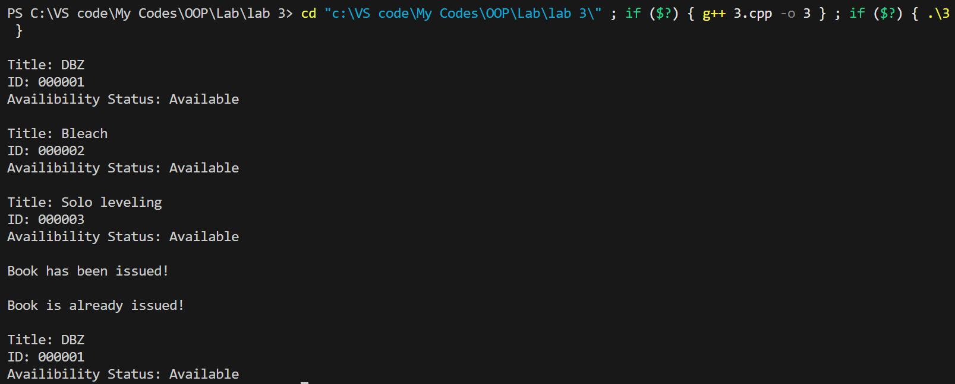

Q4.
#include <iostream>
#include <string>
using namespace std;

class Basic
{
protected:
string type;
string registrationNumber;
double Dailyrate;

public:
void setType(string t) { type = t; }
void setRegistrationNumber(string n) { registrationNumber = n; }
void setRate(double r) { Dailyrate = r; }

double calcTotal(int days, double rate)
{
// double *ptr = &total; // testing with pointer
return days * rate;
}

void printDetails(int days)
{
cout << "\nType: " << type << endl;
cout << "Registration Number: " << registrationNumber << endl;
cout << "Daily Rate: $" << Dailyrate << endl;
cout << "Total cost: $" << calcTotal(days, Dailyrate) << endl;
}
};

class Premium : public Basic
{
double insuranceCharge;
int mileageLimit;

public:
void setInsCharge(double i) { insuranceCharge = i; }
void setMileLimit(int m) { mileageLimit = m; }

void printDetails(int days)
{
cout << "\nType: " << type << endl;
cout << "Registration Number: " << registrationNumber << endl;
cout << "Daily Rate: $" << Dailyrate << endl;
cout << "Total cost: $" << (calcTotal(days, Dailyrate) + insuranceCharge) << endl;
}
};

int main()
{
Basic b1, b2;
Premium p3;
b1.setRate(5);
b1.setRegistrationNumber("001");
b1.setType("Sedan");
b2.setRate(10);
b2.setRegistrationNumber("002");
b2.setType("SUV");
p3.setInsCharge(50);
p3.setType("Luxury Car");
p3.setRate(15);
p3.setRegistrationNumber("003");
p3.setMileLimit(1000);
b1.printDetails(5);
b2.printDetails(5);
p3.printDetails(5);

return 0;
}

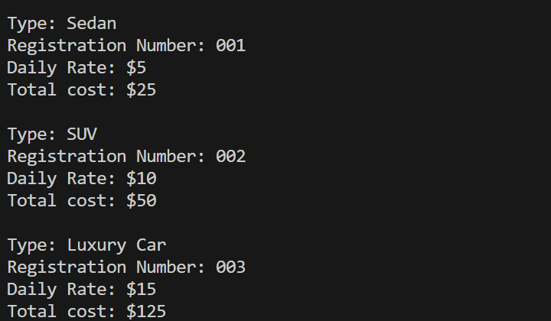

Q5.
#include <iostream>
#include <string>
using namespace std;

class Consumer
{
string name;
string ID;
int units;

public:
Consumer(string s, string i, int n) : name(s), ID(i), units(n) {}

double calcTotal(int units)
{
return (100 * 5) + (units - 100) * (10); // hardcoded rate
}

void printDetails()
{
cout << "\nName: " << name << endl;
cout << "Consumer ID: " << ID << endl;
cout << "Monthly Units used: " << units << endl;
cout << "Bill: $" << calcTotal(units) << endl;
}
};

int main()
{
Consumer abde("Abdullah", "422005", 250);
abde.printDetails();

return 0;
}

